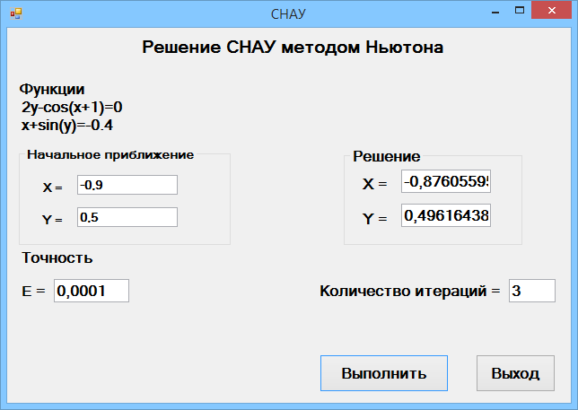

double function1(double x, double y)

{

return 2*y - cos(x + 1);

}

double function2(double x, double y)

{

return x + sin(y) + 0.4;

}

double func1x(double x, double y)

{

return sin(x + 1);

}

double func1y(double x, double y)

{

return 2.0;

}

double func2x(double x, double y)

{

return 1.0;

}

double func2y(double x, double y)

{

return cos(y);

}

private: System::Void button1_Click(System::Object^ sender, System::EventArgs^ e) {

int i = 1;

double dx, dy, d;

double x, y;

double eps;

x = Convert::ToDouble(textBox1->Text);

y = Convert::ToDouble(textBox2->Text);

eps = Convert::ToDouble(textBox3->Text);

while (fabs(fabs(function1(x, y)) - fabs(function2(x, y))) > eps){

d = cos(y)*sin(x + 1) - 2;

dx = (2 * y - cos(x + 1))*cos(y) - 2 * (x + sin(y) + 0.4);

dy = (x + sin(y) + 0.4)*sin(x + 1) - 2 * y + cos(x + 1);

x = x - dx / d;

y = y - dy / d;

i++;

}

textBox4->Text = Convert::ToString(x);

textBox5->Text = Convert::ToString(y);

textBox6->Text = Convert::ToString(i);

}